

Software Requirements Specification (SRS)

For LK-PC-Solution (Computer Items E-Commerce Website)

Version 1.0

Created By :- W. M. Lakshan Dananjana Weerasinghe

Contents

1. Introduction 3

1.1 Purpose 3

1.2 Scope 3

1.3 Definitions 3

2. Overall Description 3

2.1 User Needs 3

2.2 Assumptions 3

2.3 Constraints 3

3. System Features 4

3.1 User Registration & Authentication 4

3.2 Product Catalog 4

3.3 Shopping Cart & Checkout 4

3.4 Order Management 4

3.5 Admin Dashboard 4

4. External Interface Requirements 5

4.1 User Interface 5

4.2 APIs 5

5. Non-Functional Requirements 5

5.1 Performance 5

5.2 Security 5

5.3 Compatibility 5

6. Technologies Used 5

7. Diagrams 6

7.1 ER Diagram 6

7.2 DFD Level 0 Diagram 7

7.3 DFD Level 0 Diagram 8

7.4 Use case Diagram 9

8. Glossary 9

9. Next Steps 9

# 1. Introduction

## 1.1 Purpose

This document outlines the requirements for the LK-PC-Solution web application, a platform for selling computer hardware and accessories. It defines the scope, features, and technical specifications of the system.

## 1.2 Scope

The system will:

* Allow customers to browse and purchase computer items (e.g., CPUs, GPUs, keyboards, monitors).
* Provide administrators with tools to manage products, orders, and user accounts.
* Include a shopping cart, checkout system, and order tracking.

## 1.3 Definitions

* **User:** A registered or guest customer.
* **Admin:** A user with privileges to manage products and orders.
* **Product:** A computer item listed for sale.

# 2. Overall Description

## 2.1 User Needs

* **Customers:** Browse products, add items to cart, place orders, and track deliveries.
* **Admins:** Add/update products, manage inventory, and view sales reports.

## 2.2 Assumptions

* Users have access to a modern web browser (Chrome, Firefox, Edge).

.

## 2.3 Constraints

* Limited to desktop browsers (no dedicated mobile app).
* Built using HTML, CSS, JavaScript (frontend) and PHP (backend).

# 3. System Features

## 3.1 User Registration & Authentication

* **Description:** Users can create accounts, log in, and reset passwords.
* **Requirements:** Secure password hashing (e.g., PHP password_hash()).
* Guest checkout option.

## 3.2 Product Catalog

* **Description:** Display computer items with details (price, specs, images).
* **Requirements:** Product categorization (e.g., CPUs, GPUs, Peripherals).
* Search and filter functionality (by price, brand, category).

## 3.3 Shopping Cart & Checkout

Description: Users can add items to a cart and complete purchases.

* **Requirements**: Cart persistence using PHP sessions or cookies.
* Order confirmation email (PHP mail function or SMTP).

## 3.4 Order Management

* **Description:** Admins can view and update order statuses (e.g., "Processing," "Shipped").
* **Requirements:** Order history page for users.
* Export orders to CSV/PDF (optional).

## 3.5 Admin Dashboard

* **Description**: Admins manage products, users, and view sales analytics.
* **Requirements:** CRUD (Create, Read, Update, Delete) operations for products.
* Basic sales reports (total revenue, popular products).

# 4. External Interface Requirements

## 4.1 User Interface

* **Homepage:** Featured products, categories, and promotions.
* **Product Page:** High-quality images, specifications, and "Add to Cart" button.
* **Admin Dashboard:** Tables for products/orders, forms for adding new items.

## 4.2 APIs

* **Email Service:** PHP Mailer/SendGrid for notifications.

# 5. Non-Functional Requirements

## 5.1 Performance

* Page load time < 3 seconds.
* Support for 200+ concurrent users.

## 5.2 Security

* SQL injection prevention (PHP prepared statements).
* Cross-Site Scripting (XSS) protection (input sanitization).
* SSL certificate for HTTPS.

## 5.3 Compatibility

* Responsive design for desktop and tablet screens.

# 6. Technologies Used

* **Frontend:** HTML5, CSS3, JavaScript (Vanilla JS or jQuery).
* **Backend:** PHP (with MySQL).
* **Hosting:** Apache (e.g.,XAMPP ).

# 7. Diagrams

## 7.1 ER Diagram

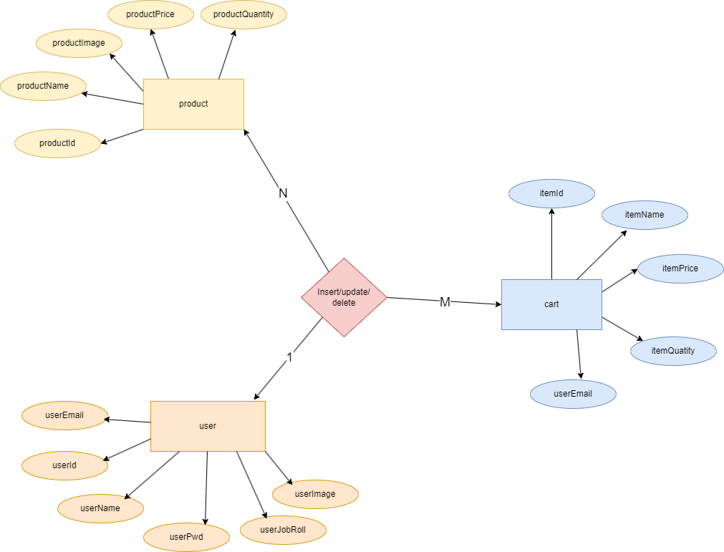

## 7.2 DFD Level 0 Diagram

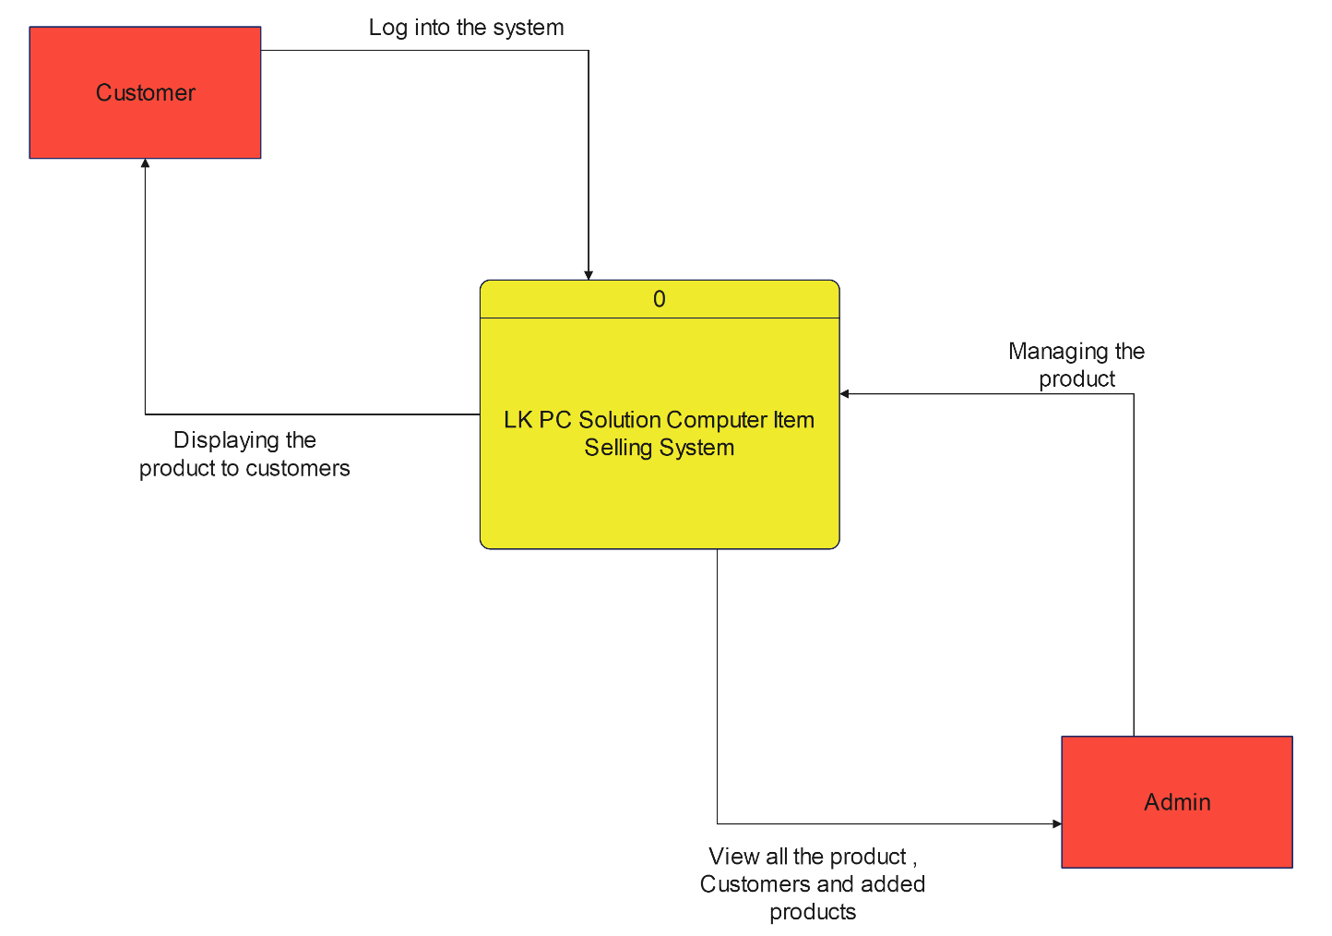

## 7.3 DFD Level 0 Diagram

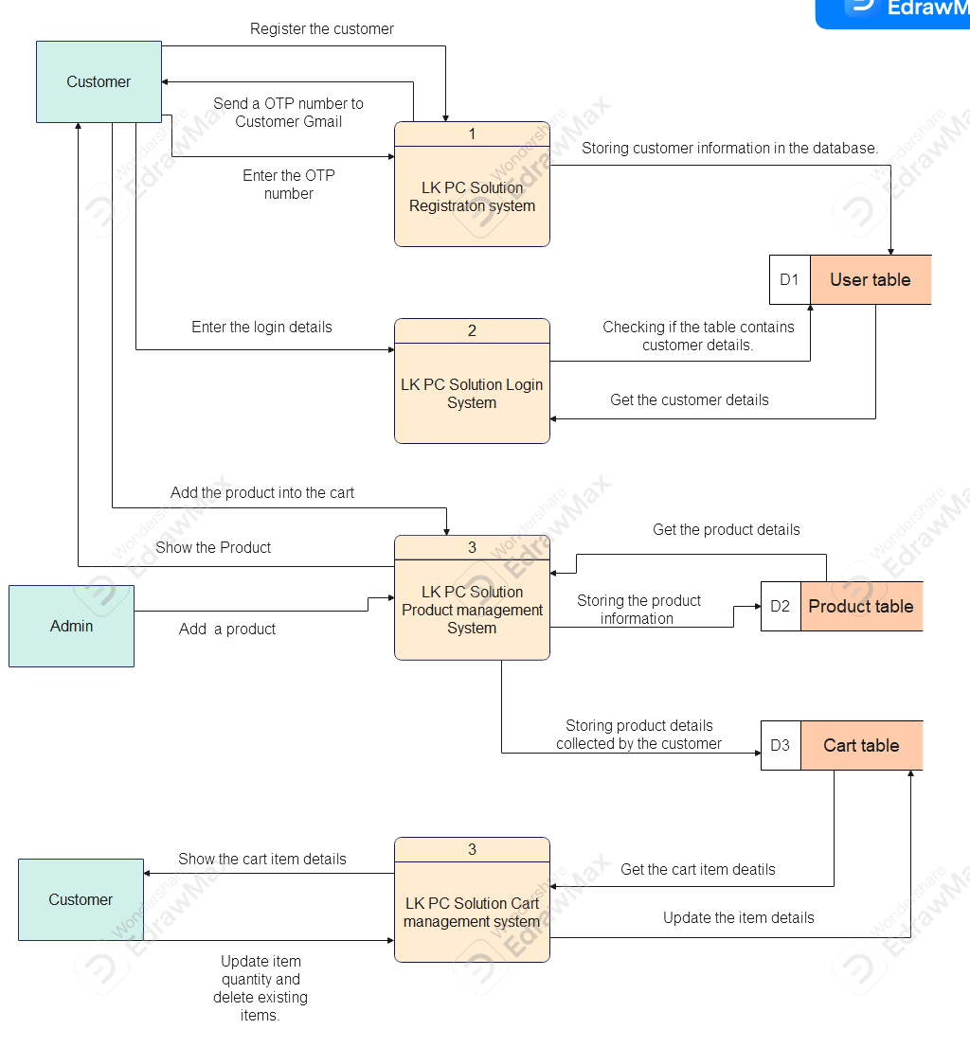

## 7.4 Use case Diagram

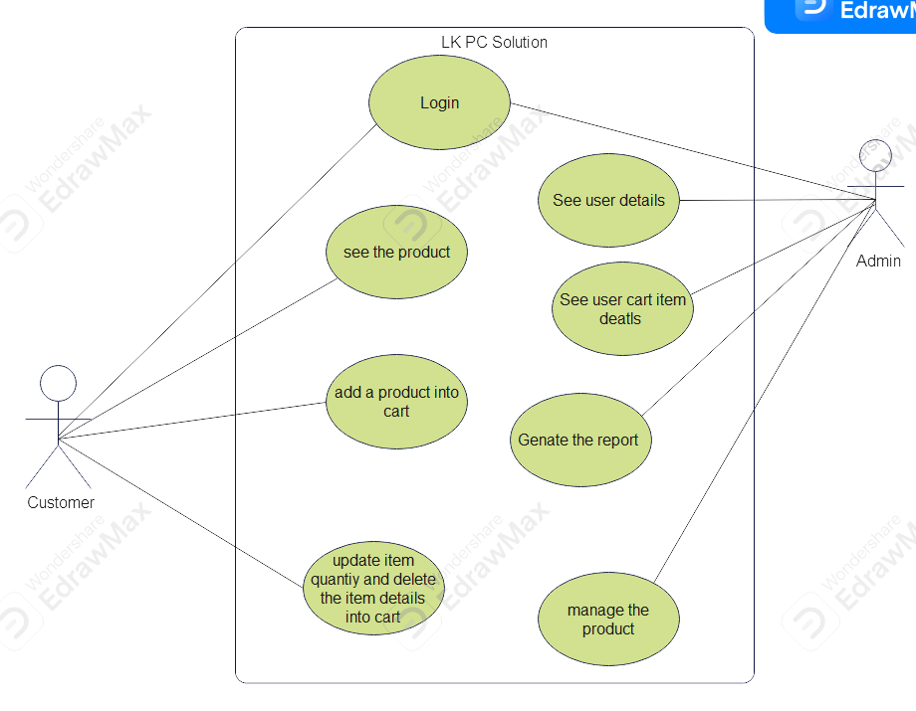

# 8. Glossary

* **CRUD:** Create, Read, Update, Delete operations.
* **SSL:** Secure Sockets Layer (encryption protocol).

# 9. Next Steps

* **Database Design:** Create tables for users, products, orders, and cart.
* **Payment Integration:** Implement PayPal/Stripe API in PHP.
* **Testing:** Validate user flows (registration, checkout, admin tasks).